Children of Nepal

“Namaste”

The newsletter of registered charity Children of Nepal Reg. No. 1059779 June 2018

Welcome and Introduction  Namaste and welcome to our June 2018 newsletter, which aims to give you an update on our projects in Nepal as well as news regarding fundraising initiatives. In particular there are reports on projects that we went to on our visit in December. Amongst the many inspiring and committed people we were fortunate enough to meet, the work of Til Bahadur Karki stands out as an incredible example of turning a very difficult personal situation into one which has benefited so many children needing support. Read more about Til Bahadur's work in this newsletter.  Visit to Nepal  In December 2017 we returned to Nepal and were pleased to be able to visit previous projects as well as new schools requiring help with classroom building projects. Further details are enclosed in this newsletter. A video montage created by Maya can be found at https://www.youtube.com/watch?v=G45ysb6lMdM&feature=youtu.be. We encountered the most wonderful hospitality and commitment to education from everyone.  Mukundasen School, Gaidakot-12  Children of Nepal previously helped Mukundasen School by providing an additional floor onto a two classroom block. The school approached us again to request help with building further classrooms. They currently run classes from Nursery to Class 8 and also require an office, library and a computer room. We have agreed to support this school with classroom building using funds donated in an individual's memory.  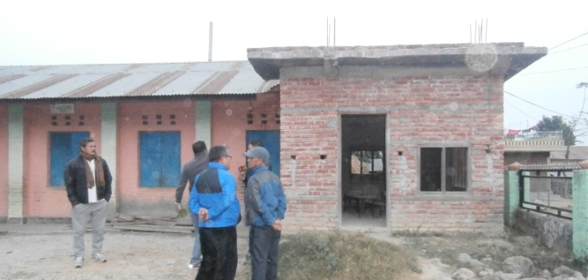  Classrooms under construction  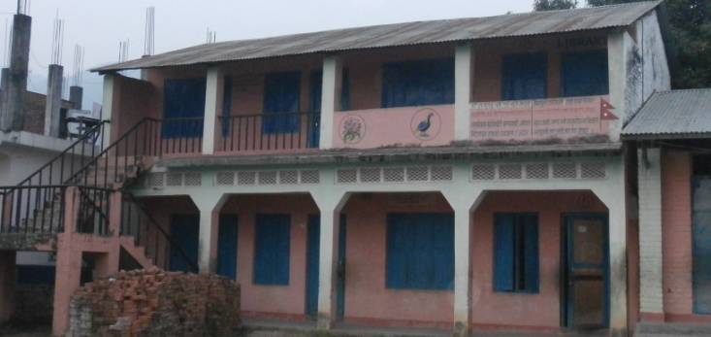  Classrooms previously built by Children of Nepal  Joint Disabled Unity Centre  We were privileged to be able to visit the children's home of Til Bahadur Karki, one of the most inspiring people we have met. Til Bahadur has established this home for children who are either disabled, or have lost their home and/or their parents due to earthquake, civil war or imprisonment. Til's story of overcoming great personal hardship and challenge is remarkable. Please see our website for further details of Til Bahadur's journey. Together with his wife and colleagues, they have set up a home for children in need, and currently look after and educate 42 children, aged 3 - 19.  The children all attend local primary or secondary schools in Gokharna, Kathmandu. They are a lovely group of children who despite their previous ordeals, are determined to make the most of future opportunities. We are pleased to be contributing towards the fees for their education. They grow their own vegetables and one of the older children who has left school now works locally. However they are dependent on support from others, so if anyone would like to donate to the Joint Disabled Unity Centre, please contact us.  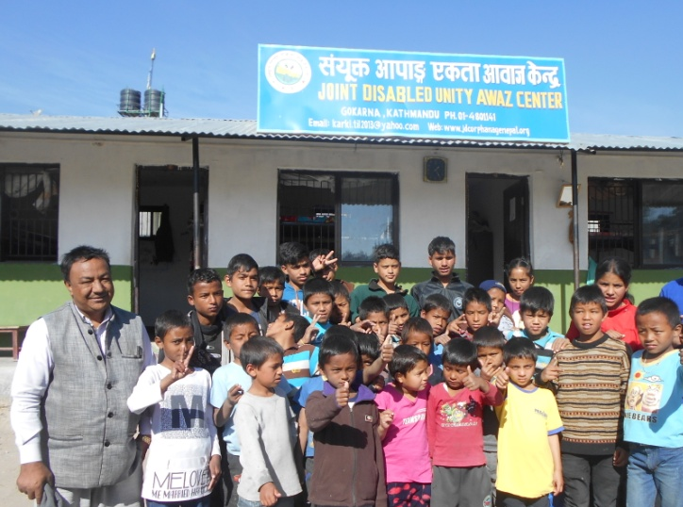  Til Bahadur Karki (left) with children from the Centre  Area of activity  There continues to be high demand for classroom building projects in government schools in our area of operation, Nawal Parasi district in central Nepal (map below). There is a mix of accessible and more remote areas - in all these, the commitment to education is really inspiring and makes us determined to provide as much help as we possibly can. Our ambition is to ensure that education becomes an achievable goal of all children where ever they may live. | Saraswati Primary, Tadi Mutikuri  There had previously been a very small primary school in the village of Tadi Mutikuri - however the funding to employ the teachers had run out 2 years ago and the major earthquakes of 2015 had damaged the classroom, by causing cracks in the walls. The community wanted to replace the damaged room and seek funding for a teacher. They therefore approached us to ask for funds for materials to build a new classroom, to restart this school. This would enable the younger children to attend school near to home, giving them the best chance of an ongoing education.  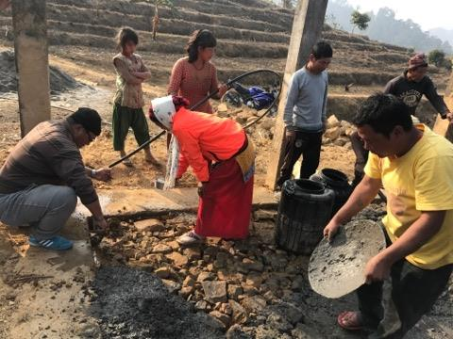  School community helping with foundation building  Once agreed, the community started the project straight away with ground clearing and building foundations. Within a few short weeks, the classroom was being built with materials provided by Children of Nepal. We look forward to seeing the completed building and supporting teacher costs, to enable this school to get back up and running.  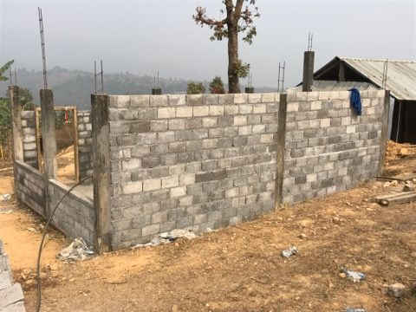  Classroom building taking shape at Tadi Mutikuri  Surya Jhoti School, Jugepani village  We were given a very warm welcome from the whole school on our recent return to Surya Jhoti School. This school has continued to develop under the leadership of a headteacher who is determined to improve the education of the children who live in the area, regardless of ethnic group. We agreed to provide funding for materials towards the completion of a 6-classroom block.  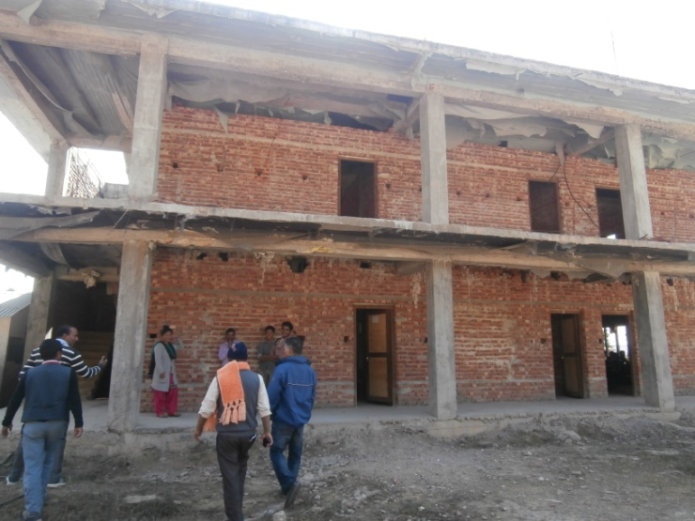  6-classroom block nearing completion, Surya Jhoti School  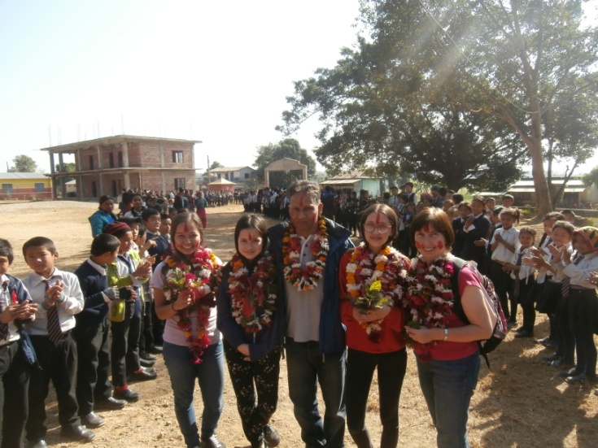  Receiving a warm welcome at Surya Jhoti School  Thank you to our donors and supporters  Thank you very much for all your donations, however large or small. We would especially like to thank Chris and Tanya Todd for their very generous donation, Cononly School, Bingley Grammar School, Louise Murfet and Ed Clarke for running the Cambridge Half Marathon for us, Karen Roem, and all those who take part in our Sponsored Bike Ride and Walk each year.  Since we started our charity work in 1997, you have helped us raise over £197,000, which is the most fantastic achievement. These funds have enabled us to complete 90 projects at 71 different schools, improving opportunities for education for the children at all these schools.

